What is Hashing? (Very Basic)
What is Hashing? (Very Basic)
Definition (Plain English)
Hashing is a one-way mathematical process that:
- Takes any size input
- Produces a fixed-length output
- Cannot be reversed back to the original input
📌 Example:

Input: password123
Hash: ef92b778bafe771e89245b89ecbc08a44a4e166c06659911881f383d4473e94f
👉 You cannot get password123 back from the hash.

2️⃣ Why Hashing Exists (Security Thinking)
Hashing exists to solve 3 critical security problems:
Problem | Without Hashing | With Hashing
Password storage | Plain text leak | Safe (hash stored)
Integrity | Data can be modified silently | Tampering detected
Verification | No proof of originality | Hash proves authenticity
📌 That’s why passwords, files, logs, certificates, blockchains all depend on hashing.

3️⃣ Hashing vs Encryption vs Encoding (VERY IMPORTANT)
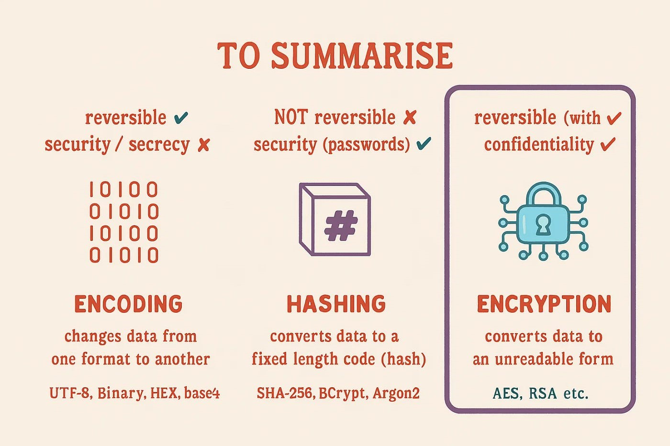

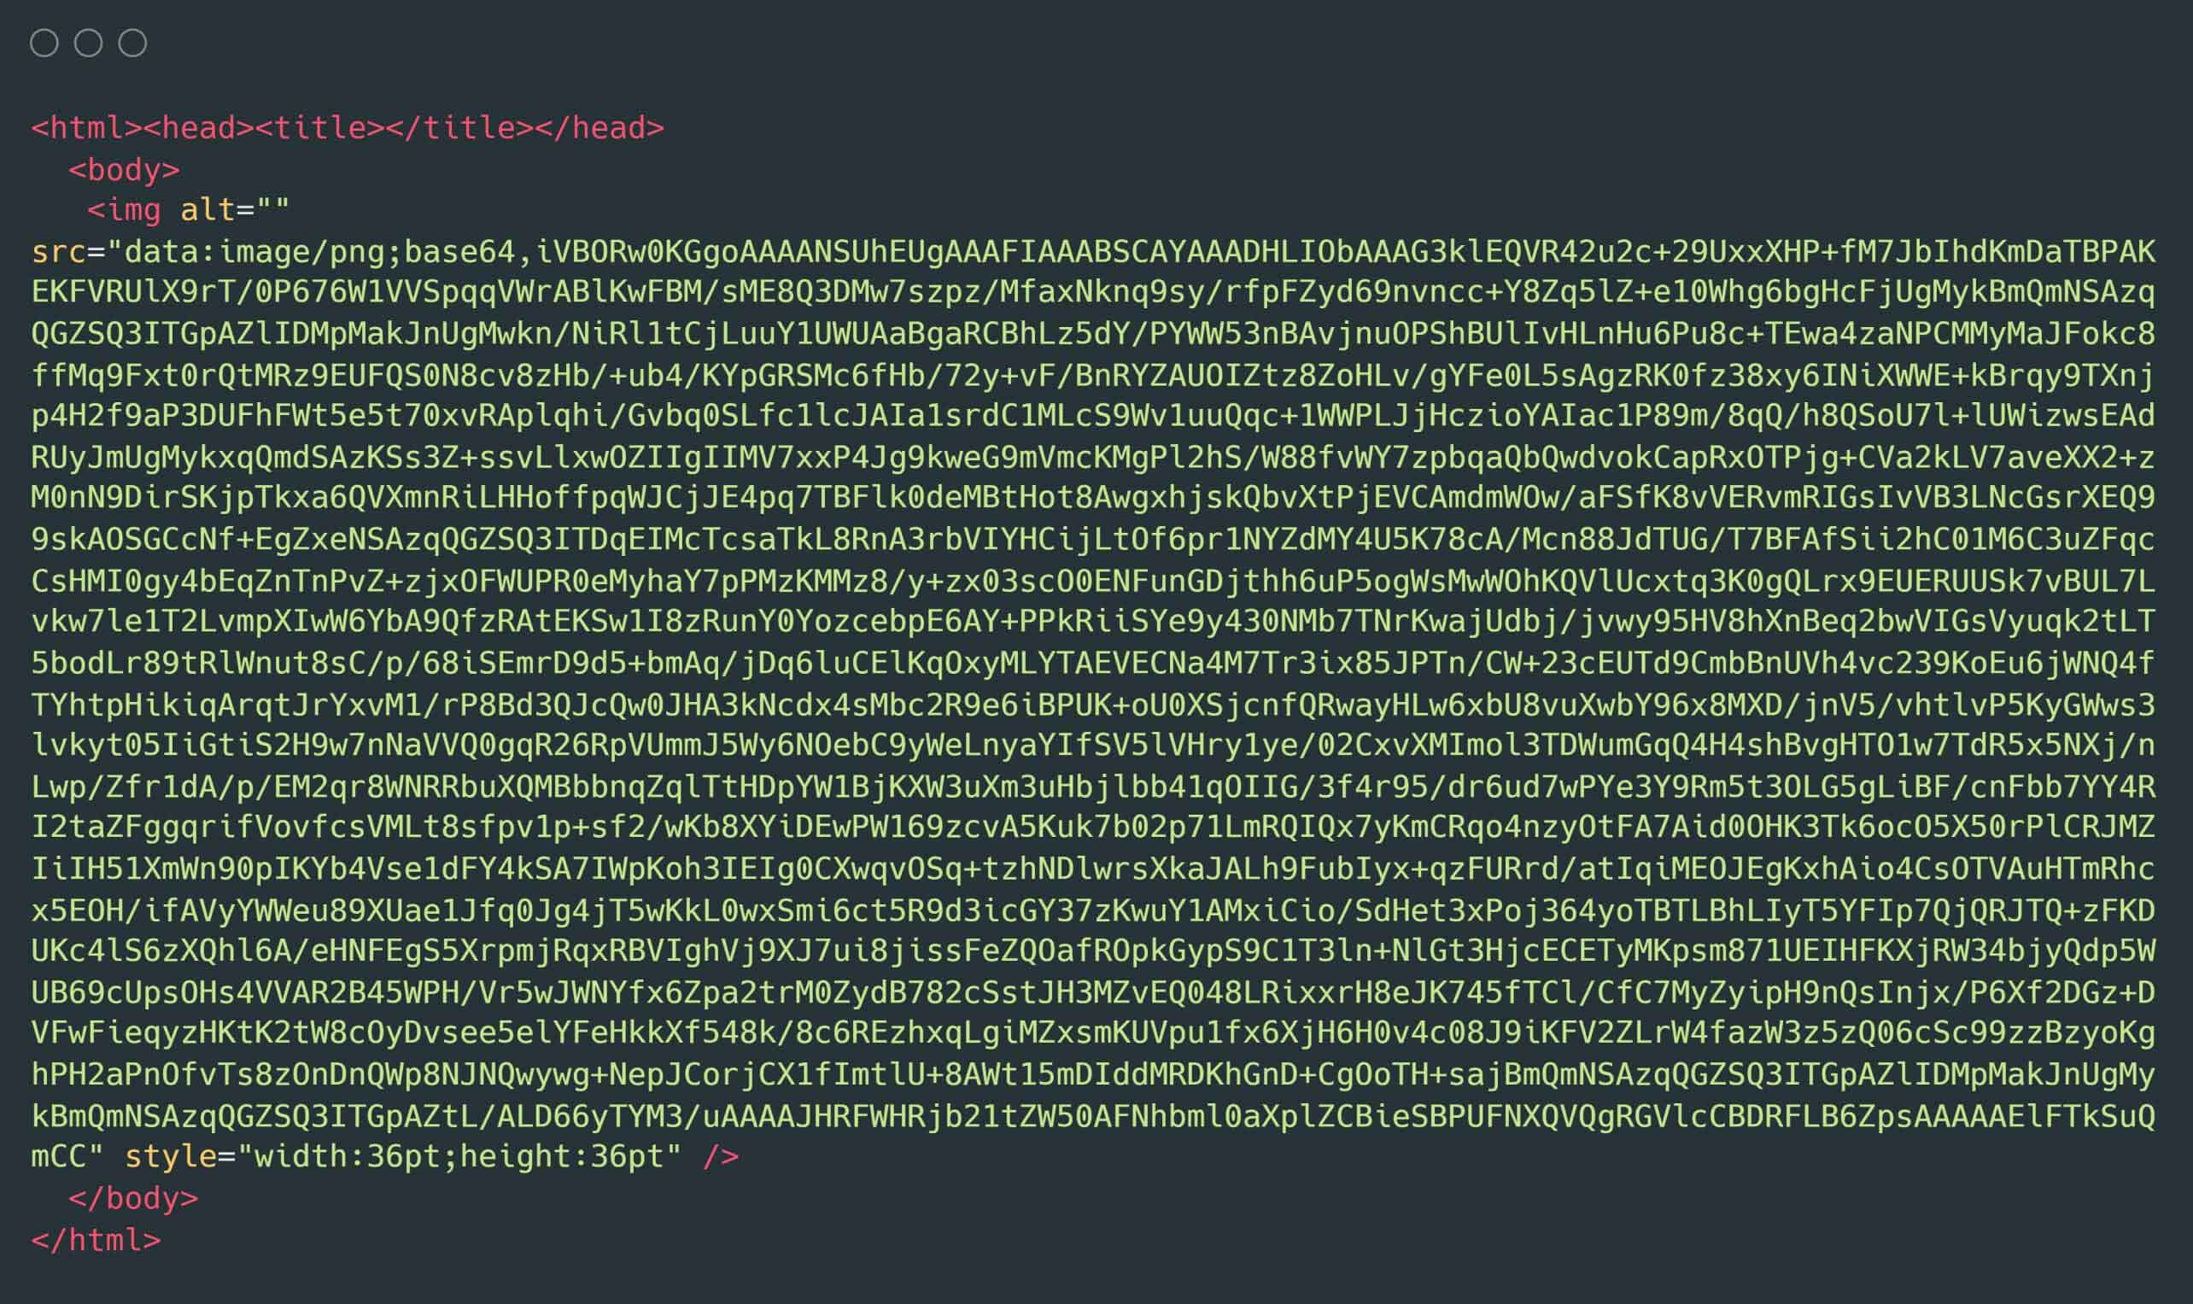
Feature | Hashing | Encryption | Encoding
Reversible | ❌ No | ✅ Yes (key) | ✅ Yes
Purpose | Integrity & verification | Confidentiality | Format change
Key used | ❌ No | ✅ Yes | ❌ No
Example | SHA-256 | AES | Base64
⚠️ Passwords must NEVER be encrypted — they must be hashed.

4️⃣ Core Properties of a Secure Hash Function
A good hash algorithm MUST satisfy:
1️⃣ Deterministic
Same input → same hash
2️⃣ Fixed Length Output
Any size input → fixed size hash
3️⃣ Avalanche Effect
Small change → completely different hash
4️⃣ Pre-image Resistance
Cannot reverse hash
5️⃣ Collision Resistance
Two inputs should NOT generate same hash

5️⃣ Popular Hash Algorithms (Explained)
Algorithm | Output Size | Status | Use
MD5 | 128-bit | ❌ Broken | Legacy only
SHA-1 | 160-bit | ❌ Broken | Legacy
SHA-256 | 256-bit | ✅ Secure | Files, passwords
SHA-512 | 512-bit | ✅ Secure | High security
bcrypt | Variable | ✅ Secure | Passwords
scrypt | Variable | ✅ Secure | Passwords
Argon2 | Variable | ✅ Best | Passwords
📌 SOC Reality:
- If you see MD5/SHA-1 → raise security finding
- If you see SHA-256 + salt → acceptable
- If you see bcrypt/Argon2 → best practice

6️⃣ Hashing LAB 1 – Basic Hash Generation (Linux)
🎯 Objective
Understand how hashing works practically.
🔧 Command

echo -n "ShadowXLab" | sha256sum
🔍 Output

5e884898da28047151d0e56f8dc6292773603d0d6aabbdd62a11ef721d1542d8
🧠 Trainer Insight
- Same input → same hash
- Change one letter → totally different hash
Try:

echo -n "shadowxlab" | sha256sum

7️⃣ Hashing LAB 2 – File Integrity Verification
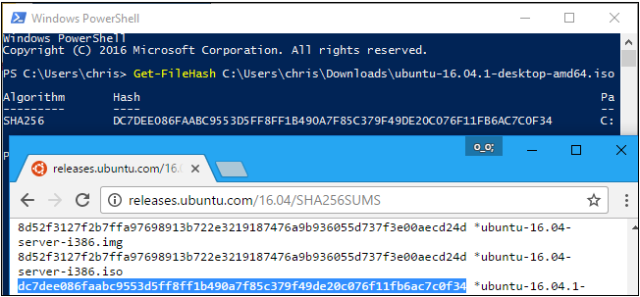

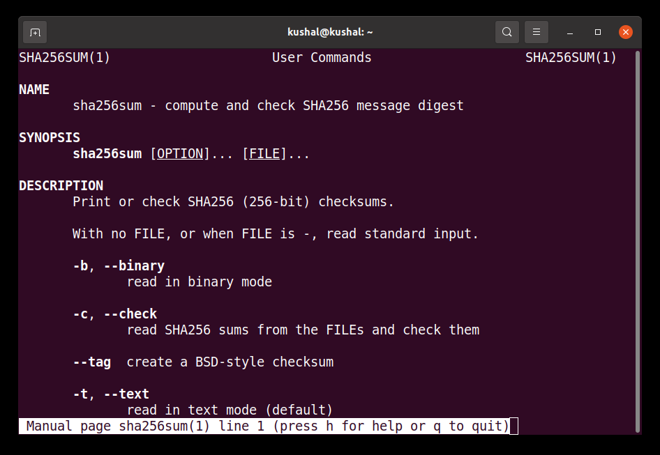

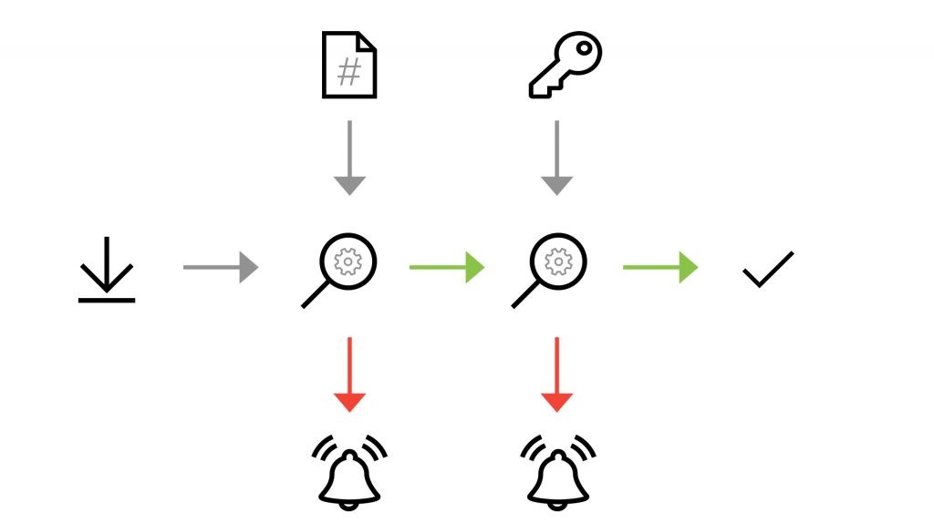
🎯 Objective
Detect file tampering (SOC & IR use case)
🔧 Step 1: Create a file

echo "Original Data" > data.txt
🔧 Step 2: Hash the file

sha256sum data.txt
🔧 Step 3: Modify the file

echo "Hacked Data" >> data.txt
🔧 Step 4: Re-hash

sha256sum data.txt
✅ Result
Hash changes → Integrity breach detected
📌 Used in:
- SOC investigations
- Malware analysis
- Legal evidence handling

8️⃣ Hashing LAB 3 – Password Hashing vs Plain Text
❌ WRONG Way

username: admin
password: admin123
✅ CORRECT Way

username: admin
password_hash: $2b$12$wP9...
📌 Even if DB is hacked → attacker does not get passwords

9️⃣ Salt & Why It Is Mandatory
Problem (Without Salt)

password123 → same hash everywhere
Solution (With Salt)
salt + password → unique hash
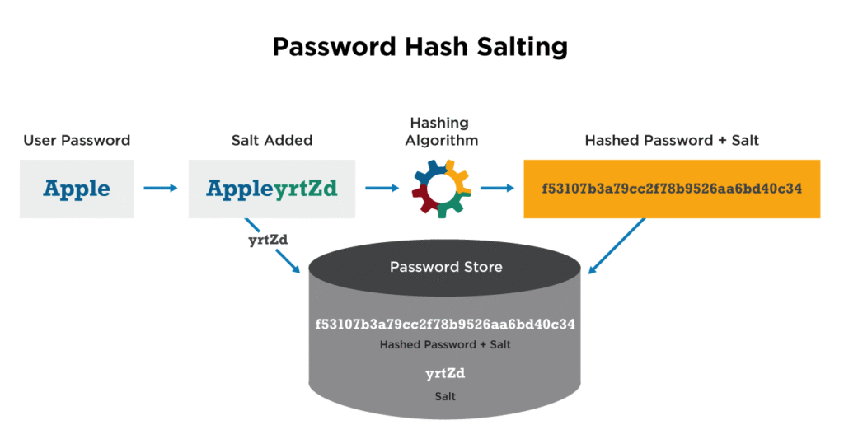

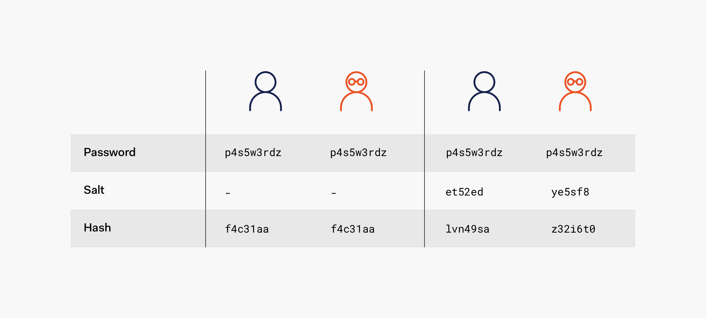

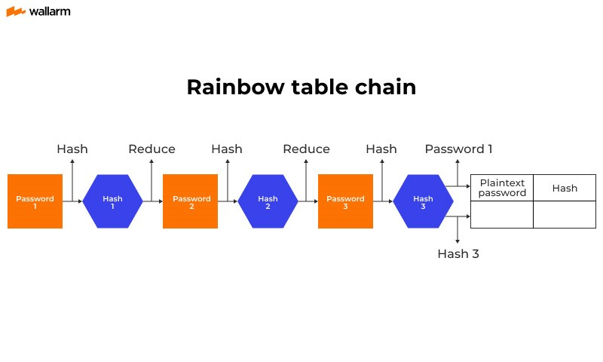
🔧 Example

echo -n "SALT123password123" | sha256sum
📌 Salt defeats:
- Rainbow table attacks
- Mass password cracking

🔟 Hashing LAB 4 – Hash Cracking Demo (Awareness Lab)
⚠️ For education only
🔧 Create hash

echo -n "admin123" | md5sum
🔧 Crack using wordlist

hashcat -m 0 hash.txt rockyou.txt
🧠 Lesson
- Weak hash + no salt = instant compromise
- This is why MD5/SHA-1 are banned

1️⃣1️⃣ Hashing in SOC & Enterprise
Area | Hash Usage
SOC | Malware hash matching
IR | Evidence integrity
IAM | Password storage
GRC | Compliance validation
Blockchain | Block linking
PKI | Certificate fingerprints

1️⃣2️⃣ Compliance & Standards Mapping
Standard | Requirement
ISO 27001 | Integrity controls
PCI DSS | Strong hashing for CHD
NIST | SHA-2 / SHA-3
DPDP Act 2023 | Secure credential storage

🔥 Interview Kill Statements (Use These)
- “Hashing is one-way; encryption is reversible.”
- “Passwords must always be hashed + salted, never encrypted.”
- “MD5 is fast — that’s why it’s insecure.”
- “Integrity checks rely entirely on hash comparison.”

✅ What You’ve Mastered
✔ Hash fundamentals
✔ Algorithms & security status
✔ Real Linux labs
✔ SOC & GRC mapping
✔ Interview-ready clarity

